**Unit 7 Summary Measures Worksheet**

**Exercise 6.1**

*Q: Open the Excel workbook Exa 8.1B.xlsx from the Exercises folder. Obtain the sample size, sample mean weight loss and the sample standard deviation of the weight loss for Diet B. Place these results in the block of cells F23 to F25, using the same format as that employed for the Diet A results in the above example. Briefly interpret your findings. What do these results tell you about the relative effectiveness of the two weight-reducing diets?*

A: The sample mean weight loss for Diet B is 3.710 kg with a sample standard deviation of 2.769 and this proves that the Diet B was also effective for the weight loss.However since the mean weight loss of Diet A is higher compared to Diet B, it may be that Diet A was more effective than Diet B.

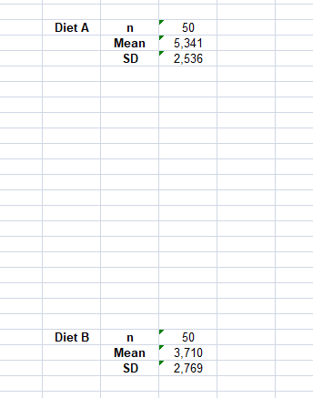

**Exercise 6.2**

*Q: Open the Excel workbook Exa 8.2B.xlsx from the Exercises folder. Obtain the sample median, first and third quartiles and the sample interquartile range of the weight loss for Diet B. Place these results in the block of cells F26 to F29, using the same format as that employed for the Diet A results in the above example. Briefly interpret your findings. What do these results tell you about the relative effectiveness of the two weight-reducing diets?*

A: The sample median weight loss for Diet B is M 3.745 kg, and the diet appears to have also been effective .However this is lower than the median weight loss of Diet A, suggesting that Diet B is less effective than Diet A at weight loss. The sample interquartile range of the weight loss for Diet B is IQR = 3.451 kg. This indicates a moderate spread in the middle 50% of weight loss results, with some individuals achieving substantial weight loss while others experienced less significant results. A proportion of individuals on Diet B achieved positive weight loss, but the lower median weight loss and broader variability suggest that Diet B may not be as consistently effective as Diet A.

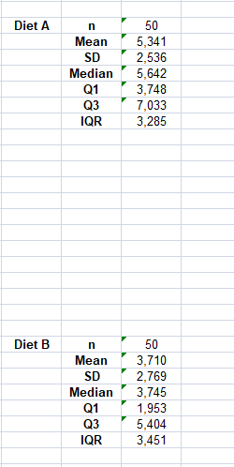

**Exercise 6.3**

*Q: Open the Excel workbook Exa 8.3D.xlsx from the Exercises folder. Obtain the frequencies and percentage frequencies of the variable Brand, but this time for the Area 2 respondents, using the same format as that employed for the Area1 results in the above example. Briefly interpret your findings. What do these results tell you about the patterns of brand preferences for each of the two demographic areas?*

A: Preference for Brand A is greater in Area 2 (21%) than in Area 1 (16%).This suggests that Brand A is relatively more popular in Area 2 compared to Area 1. Preference for Brand B is significantly higher in Area 2 (33%) than in Area 1 (24%).This indicates that Brand B also enjoys greater popularity in Area 2.Preference for other brands is lower in Area 2 (46%) than in Area 1 (60%).This suggests that the manufacturer’s brands (A and B) are more popular in Area 2, with fewer respondents preferring other brands.

